IS 436 - Structured System Analysis & Design

Deliverable 4 - Data Modeling and Starting Design

Team Members:

Adam Afilaka: Developer/Programmer (aafilak1@umbc.edu)

Ashley Braun: Business Analyst/Legal Compliance/Project Manager (410-991-1496; abraun1@umbc.edu)

Zaid Islam: Cyber Security Engineer (240-688-5964) (zislam1@umbc.edu)

Rithika Sayini: Researcher/Programmer (rithika1@umbc.edu)

Shanese Scott: Database Administrator (443-760-1459; scsh1@umbc.edu)

Xin Zheng: Quality Assurance(443-931-9403; xinz1@umbc.edu)

November 21, 2019

**Part 1 - ER Diagram:**

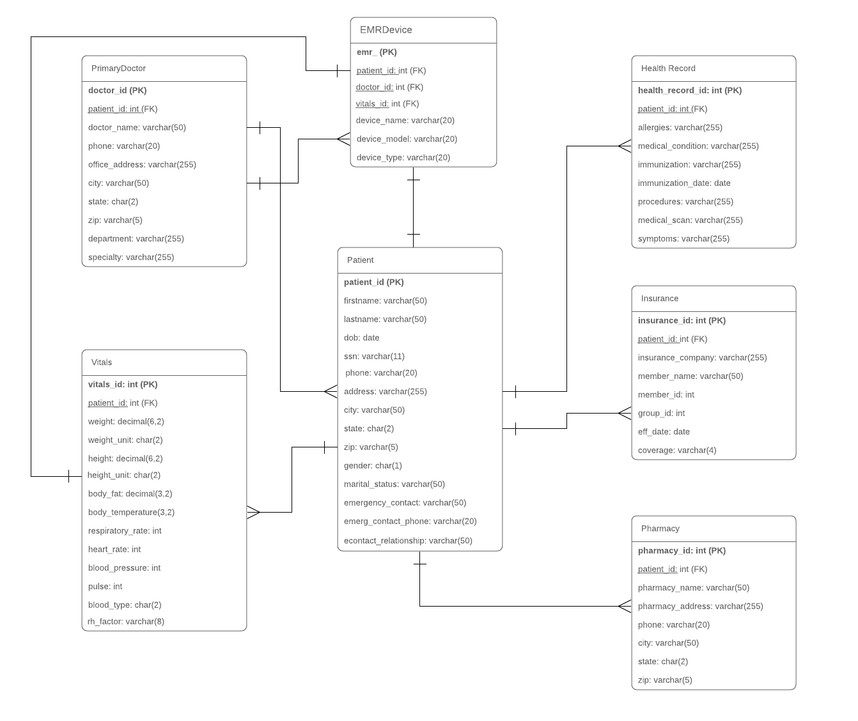

Description:

Each of the tables in the ER diagram have a relationship with the patient. In each of these tables the patient_id is a foreign key. The patient table includes basic information about the patient such as their name, ssn, and emergency contacts. The EMR device has a type, name, and model and has a one to one relationship with the patient. Each EMR device must only record information from the patient it’s registered to. Next, each patient can have multiple health records. These records include information about medical scans such as MRIs, EKGs, and Xrays. Previous or current immunizations and medical conditions are also stored here. It is expected that each patient has at least one form of insurance so the relationship is stated as one to many. This table lists who their insurance company is as well as their member id and coverage plan. Next, the pharmacy is listed as a one to one relationship with the patient. Most patients have a primary pharmacy that they request to get medications from. This table includes basic contact information about the pharmacy. The relationship between the patient and their vitals are one to many. At the time of analysis, the device only picks up the patient’s current vitals and that information is updated to the database. Previous vital signs are also stored to compare with current ones. Lastly, the doctor table has a one to one relationship with the patient. Patient’s only have one primary care doctor and that is the only one who can have access to the patient’s vitals. However, the doctor can have access to multiple patients and multiple vitals.

3NF:

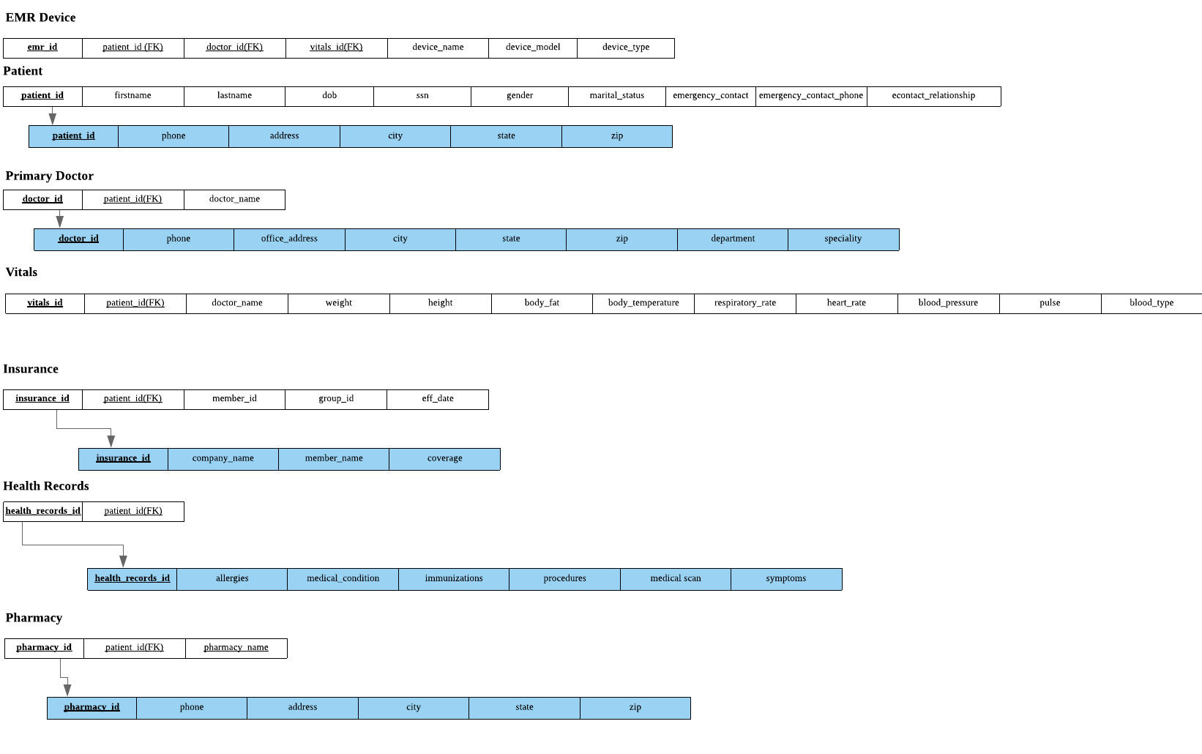

**Part 2 - Alternative Matrix**

***Note, Scoring key: 1 = poor fit; 5 = perfect fit***

**Ashley’s:**

|  |  |  |  |  |  |  |  |  |  |  |
| --- | --- | --- | --- | --- | --- | --- | --- | --- | --- | --- |
| Evaluation Criteria | Relative Importance | Alternative1: Wearable EMR Device | Score | Wtd.  Score | Alternative 2: Card form EMR | Score | Wtd.  Score | Alternative 3: Skin Patch/Chip | Score | Wtd.  Score |
| Technical Issues | | | | | | | | | |  |
| Integration with existing Systems | 25 | Has the capability to accept old & new program languages. | 4 | 100 | Not fully. Lacks efficacy to track active patient vitals/ data. | 1 | 25 | Developed to have capability. | 2 | 50 |
| Experience with the Device | 10 | Depends on person/ entity and comfort level with wearable technology. Teachable. | 3 | 30 | Yes. | 4 | 40 | Fewer individuals have experience. Patients do not need experience to utilize. | 3 | 30 |
| Compatibility with other Systems | 25 | Some devices already exist that are. The goal is to create a universally compatible product. | 3 | 75 | Not compatible with all components of the system (e.g., vitals, chemistry changes) | 1 | 25 | Yes. | 3 | 75 |
| Economic Issues it | | | | | | | | | |  |
| Costs | 20 | Expensive | 3 | 60 | Less Expensive | 3 | 60 | Expensive | 2 | 40 |
| Organizational Issues | | | | | | | | | |  |
| Training to Use the System | 15 | Time-intensive/Costly at the commercial/IT level. Device itself is user-friendly. | 4 | 60 | Training on a commercial/IT level, but not needed for patients. | 4 | 60 | Training on a commercial/IT level; minor training at patient level. | 3 | 45 |
| Demonstrated product in market | 5 | Yes, similar, less complex systems (FitBit, Apple Watch) exist. | 5 | 25 | Yes. We currently use cards to access data. | 3 | 15 | Yes, similar, less complex systems (heart monitors, patches) exist. | 3 | 15 |
| **Total** | 100 |  | 22 | 350 |  | 16 | 225 |  | 16 | 255 |

**Adam’s:**

|  |  |  |  |  |  |  |  |  |  |  |
| --- | --- | --- | --- | --- | --- | --- | --- | --- | --- | --- |
| Evaluation Criteria | Relative Importance | Alternative1: Wearable EMR Device | Score | Wtd.  Score | Alternative 2: Card form EMR | Score | Wtd.  Score | Alternative 3: Skin Patch/Chip | Score | Wtd.  Score |
| Technical Issues | | | | | | | | | |  |
| Integration with existing Systems | 20 | Has the capability to accept old & new program languages. | 4 | 80 | Not fully. Lacks efficacy to track active patient vitals/ data. | 2 | 40 | Developed to have capability. | 4 | 80 |
| Experience with the Device | 15 | Depends on person/ entity and comfort level with wearable technology. | 4 | 60 | Yes. | 4 | 60 | Fewer individuals have experience. Patients do not need experience to utilize. | 4 | 60 |
| Compatibility with other Systems | 25 | Some devices already exist that are. The goal is to create a universally compatible product. | 4 | 100 | Not compatible with all components of the system (e.g., vitals, chemistry changes) | 2 | 50 | Yes. | 5 | 125 |
| Economic Issues | | | | | | | | | |  |
| Costs | 10 | Expensive | 3 | 30 | Less Expensive | 3 | 30 | Expensive | 3 | 30 |
| Organizational Issues | | | | | | | | | |  |
| Training to Use the System | 20 | Time-intensive/Costly at the commercial/IT level. Device itself is user-friendly. | 4 | 80 | Training on a commercial/IT level, but not needed for patients. | 3 | 60 | Training on a commercial/IT level; minor training at patient level. | 4 | 80 |
| Demonstrated product in market | 10 | Yes, similar, less complex systems (FitBit, Apple Watch) exist. | 3 | 30 | Yes. We currently use cards to access data. | 3 | 30 | Yes, similar, less complex systems (heart monitors, patches) exist. | 4 | 40 |
| **Total** | 100 |  | 32 | 410 |  | 17 | 270 |  | 23 | 415 |

**Xin’s:**

|  |  |  |  |  |  |  |  |  |  |  |
| --- | --- | --- | --- | --- | --- | --- | --- | --- | --- | --- |
| Evaluation Criteria | Relative Importance | Alternative1: Wearable EMR Device | Score | Wtd.  Score | Alternative 2: Card form EMR | Score | Wtd.  Score | Alternative 3: Skin Patch/Chip | Score | Wtd.  Score |
| Technical Issues | | | | | | | | | |  |
| Integration with existing Systems | 30 | Has the capability to accept old & new program languages. | 4 | 70 | Not fully. Lacks efficacy to track active patient vitals/ data. | 3 | 90 | Developed to have capability. | 4 | 120 |
| Experience with the Device | 15 | Depends on person/ entity and comfort level with wearable technology. | 3 | 45 | Yes. | 3 | 45 | Fewer individuals have experience. Patients do not need experience to utilize. | 4 | 60 |
| Compatibility with other Systems | 20 | Some devices already exist that are. The goal is to create a universally compatible product. | 3 | 60 | Not compatible with all components of the system (e.g., vitals, chemistry changes) | 3 | 60 | Yes. | 5 | 100 |
| Economic Issues | | | | | | | | | |  |
| Costs | 20 | Expensive | 3 | 60 | Less Expensive | 4 | 80 | Expensive | 3 | 60 |
| Organizational Issues | | | | | | | | | |  |
| Training to Use the System | 5 | Time-intensive/Costly at the commercial/IT level. Device itself is user-friendly. | 4 | 20 | Training on a commercial/IT level, but not needed for patients. | 3 | 15 | Training on a commercial/IT level; minor training at patient level. | 4 | 20 |
| Demonstrated product in market | 10 | Yes, similar, less complex systems (FitBit, Apple Watch) exist. | 4 | 40 | Yes. We currently use cards to access data. | 3 | 30 | Yes, similar, less complex systems (heart monitors, patches) exist. | 4 | 40 |
| **Total** | 100 |  | 21 | 295 |  | 19 | 320 |  | 24 | 400 |

**Rithika’s:**

|  |  |  |  |  |  |  |  |  |  |  |
| --- | --- | --- | --- | --- | --- | --- | --- | --- | --- | --- |
| Evaluation Criteria | Relative Importance | Alternative1: Wearable EMR Device | Score | Wtd.  Score | Alternative 2: Card form EMR | Score | Wtd.  Score | Alternative 3: Skin Patch/Chip | Score | Wtd.  Score |
| Technical Issues | | | | | | | | | |  |
| Integration with existing Systems | 30 | Has the capability to accept old & new program languages. | 4 | 120 | Not fully. Lacks efficacy to track active patient vitals/ data. | 2 | 60 | Developed to have capability. | 5 | 150 |
| Experience with the Device | 15 | Depends on person/ entity and comfort level with wearable technology. | 3 | 45 | Yes. | 3 | 45 | Fewer individuals have experience. Patients do not need experience to utilize. | 5 | 75 |
| Compatibility with other Systems | 25 | Some devices already exist that are. The goal is to create a universally compatible product. | 4 | 100 | Not compatible with all components of the system (e.g., vitals, chemistry changes) | 3 | 75 | Yes. | 5 | 125 |
| Economic Issues | | | | | | | | | |  |
| Costs | 10 | Expensive | 4 | 40 | Less Expensive | 3 | 30 | Expensive | 4 | 40 |
| Organizational Issues | | | | | | | | | |  |
| Training to Use the System | 10 | Time-intensive/Costly at the commercial/IT level. Device itself is user-friendly. | 4 | 40 | Training on a commercial/IT level, but not needed for patients. | 4 | 40 | Training on a commercial/IT level; minor training at patient level. | 5 | 50 |
| Demonstrated product in market | 10 | Yes, similar, less complex systems (FitBit, Apple Watch) exist. | 4 | 40 | Yes. We currently use cards to access data. | 4 | 40 | Yes, similar, less complex systems (heart monitors, patches) exist. | 5 | 50 |
| **Total** | 100 |  | 23 | 385 |  | 19 | 290 |  | 29 | 490 |

**Shanese’s:**

|  |  |  |  |  |  |  |  |  |  |  |
| --- | --- | --- | --- | --- | --- | --- | --- | --- | --- | --- |
| Evaluation Criteria | Relative Importance | Alternative1: Wearable EMR Device | Score | Wtd.  Score | Alternative 2: Card form EMR | Score | Wtd.  Score | Alternative 3: Skin Patch/Chip | Score | Wtd.  Score |
| Technical Issues | | | | | | | | | |  |
| Integration with existing Systems | 20 | Has the capability to accept old & new program languages. | 3 | 50 | Not fully. Lacks efficacy to track active patient vitals/ data. | 2 | 50 | Developed to have capability. | 5 | 130 |
| Experience with the Device | 15 | Depends on person/ entity and comfort level with wearable technology. | 5 | 70 | Yes | 4 | 70 | Fewer individuals have experience. Patients do not need experience to utilize. | 3 | 65 |
| Compatibility with other Systems | 25 | Some devices already exist that are. The goal is to create a universally compatible product. | 3 | 65 | Not compatible with all components of the system (e.g., vitals, chemistry changes) | 5 | 80 | Yes | 4 | 120 |
| Economic Issues | | | | | | | | | |  |
| Cost | 20 | Expensive | 4 | 40 | Less Expensive | 3 | 30 | Expensive | 5 | 50 |
| Organizational Issues | | | | | | | | | |  |
| Training to use the System | 10 | Time-intensive/Costly at the commercial/IT level. Device itself is user-friendly. | 4 | 30 | Training on a commercial/IT level, but not needed for patients. | 4 | 40 | Training on a commercial/IT level; minor training at patient level. | 3 | 30 |
| Demonstrated product in market | 10 | Yes, similar, less complex systems (FitBit, Apple Watch) exist. | 5 | 70 | Yes. We currently use cards to access data. | 3 | 30 | Yes, similar, less complex systems (heart monitors, patches) exist. | 5 | 50 |
| **Total** | 100 |  | 25 | 325 |  | 21 | 300 |  | 25 | 445 |

**Zaid’s:**

|  |  |  |  |  |  |  |  |  |  |  |
| --- | --- | --- | --- | --- | --- | --- | --- | --- | --- | --- |
| Evaluation Criteria | Relative Importance | Alternative1: Wearable EMR Device | Score | Wtd.  Score | Alternative 2: Card form EMR | Score | Wtd.  Score | Alternative 3: Skin Patch/Chip | Score | Wtd.  Score |
| Technical Issues | | | | | | | | | |  |
| Integration with existing Systems | 15 | Has the capability to accept old & new program languages. | 1 | 15 | Not fully. Lacks efficacy to track active patient vitals/ data. | 5 | 75 | Developed to have capability. | 3 | 45 |
| Experience with the Device | 15 | Depends on person/ entity and comfort level with wearable technology. | 3 | 45 | Yes. | 5 | 75 | Fewer individuals have experience. Patients do not need experience to utilize. | 4 | 60 |
| Compatibility with other Systems | 10 | Some devices already exist that are. The goal is to create a universally compatible product. | 1 | 10 | Not compatible with all components of the system (e.g., vitals, chemistry changes) | 1 | 10 | Yes. | 5 | 50 |
| Economic Issues | | | | | | | | | |  |
| Costs | 25 | Expensive | 5 | 125 | Less Expensive | 3 | 75 | Expensive | 4 | 100 |
| Organizational Issues | | | | | | | | | |  |
| Training to Use the System | 15 | Time-intensive/Costly at the commercial/IT level. Device itself is user-friendly. | 5 | 75 | Training on a commercial/IT level, but not needed for patients. | 2 | 30 | Training on a commercial/IT level; minor training at patient level. | 5 | 75 |
| Demonstrated product in market | 20 | Yes, similar, less complex systems (FitBit, Apple Watch) exist. | 1 | 20 | Yes. We currently use cards to access data. | 3 | 60 | Yes, similar, less complex systems (heart monitors, patches) exist. | 5 | 100 |
| **Total** | 100 |  | 16 | 290 |  | 19 | 325 |  | 26 | 430 |

**Team Matrix:**

|  |  |  |  |  |  |  |  |  |  |  |
| --- | --- | --- | --- | --- | --- | --- | --- | --- | --- | --- |
| Evaluation Criteria | Relative Importance | Alternative1: Wearable EMR Device | Score | Wtd.  Score | Alternative 2: Card form EMR | Score | Wtd.  Score | Alternative 3: Skin Patch/Chip | Score | Wtd.  Score |
| Technical Issues | | | | | | | | | |  |
| Integration with existing Systems | 25 | Has the capability to accept old & new program languages. | 3 | 75 | Not fully. Lacks efficacy to track active patient vitals/ data. | 3 | 75 | Developed to have capability. | 4 | 100 |
| Experience with the Device | 15 | Depends on person/ entity and comfort level with wearable technology. | 4 | 60 | Yes. | 4 | 60 | Fewer individuals have experience. Patients do not need experience to utilize. | 4 | 60 |
| Compatibility with other Systems | 20 | Some devices already exist that are. The goal is to create a universally compatible product. | 3 | 60 | Not compatible with all components of the system (e.g., vitals, chemistry changes) | 3 | 60 | Yes. | 5 | 100 |
| Economic Issues | | | | | | | | | |  |
| Costs | 20 | Expensive | 4 | 80 | Less Expensive | 3 | 60 | Expensive | 4 | 80 |
| Organizational Issues | | | | | | | | | |  |
| Training to Use the System | 10 | Time-intensive/Costly at the commercial/IT level. Device itself is user-friendly. | 4 | 40 | Training on a commercial/IT level, but not needed for patients. | 3 | 30 | Training on a commercial/IT level; minor training at patient level. | 4 | 40 |
| Demonstrated product in market | 10 | Yes, similar, less complex systems (FitBit, Apple Watch) exist. | 4 | 40 | Yes. We currently use cards to access data. | 3 | 30 | Yes, similar, less complex systems (heart monitors, patches) exist. | 4 | 40 |
| **Total** | 100 |  | 22 | 355 |  |  | 315 |  | 25 | 420 |

**Part 3** - **Architectural Design Matrix**

|  |  |  |  |  |  |
| --- | --- | --- | --- | --- | --- |
| **REQUIREMENTS** | Sever-Based | Client-Based | Thin-Client Based | Thick-Client-Based | 3-tiered |
| Operational |  |  |  |  |  |
| Tech Environment |  |  | X |  | X |
| System Integration |  | X | X |  | X |
| Maintenance | X |  |  |  |  |
| Portability |  | X | X |  |  |
| Performance |  |  |  |  |  |
| Reliability |  | X | X |  | X |
| Time Lapse |  | X | X |  |  |
| Capacity |  |  |  |  | X |
| Security |  |  |  |  |  |
| Encryption | X |  | X |  | X |
| Detection | X |  |  |  | X |
| Virus Control | X |  | X |  | X |
| Cultural/Political |  |  |  |  |  |
| Language |  |  | X |  | X |
| Legal Protocols |  |  |  |  | X |

**Description**

In an effort to select the optimal architecture for this system, it is important to address that information (as seen in our ER) is coming directly from EMR devices worn by patients.There is no data that is needed to be transmitted back to clients. Therefore, the need for a server-based system architecture is to no effect. Another important factor is that since the patients are disbursed and collected to a client so it would be redundant to a Thick-Client Based or Thin-Based since there a collected client source reporting to a server would require unnecessary routers and switches to be compatible, given the technology available.

Due to the complexity and prioritization of reliable and secure information being sent 3-Tiered Client-Server Architecture is needed. This is because the client devices needs an application server to monitor and determine when to send crucial data to important databases that gives secure information to the Doctor. Since the EMR is being read constantly the load on a single server to monitor and know when to alert can cause congestion and delay. Although it can be argued more special server (n-tiered) would also help with different applications. Since the process and system would not need other applications to be run, it would be more cost-effective to stick to a 3-Tiered Architecture. This architecture also is reliable for security, and authorization as it prevents unwanted data to be sent to important database server which can be examined be applications-based servers. Some advantages of this include: Extensive customization options, including integration with other practice management software through third-party interfaces. Total control over data and hardware; both reside in your practice.It also does not require Internet connectivity except for external interfaces (lab, e-prescribe, diagnostic imaging). It has faster processing speed; can handle larger file sizes such as images. Lastly, less expensive over the long haul

**Hardware and Software Specifications**

|  |  |  |  |
| --- | --- | --- | --- |
|  | EMR Devices | Medical Record Server | EMR Data Server |
| **Operating System** | * Kareo Clinical EHR * [Intergy by Greenway Health](https://www.softwareadvice.com/medical/greenway-health-intergy-profile/) | Oracle  Linux | Oracle (Cross-Platform) |
| **Special Software** | * C (Core) * Java | * Oracle Application Server Containers for Java EE (OC4J) | * Oracle Portal * Oracle Identity Management * Oracle Business Rules * Oracle Business Activity Monitoring * Oracle Business Intelligence * [Oracle Reports](https://en.wikipedia.org/wiki/Oracle_Reports) * [JDeveloper](https://en.wikipedia.org/wiki/Oracle_JDeveloper) * Oracle Application Server Containers for Java EE (OC4J) * Oracle Application Server Wireless |
| **Hardware** | 32-bit ARM  MIPS | **I**BM z15™ | IBM Power System S922 |
| **Network** | Wireless | Wireless | Wireless |

**Project Plan**

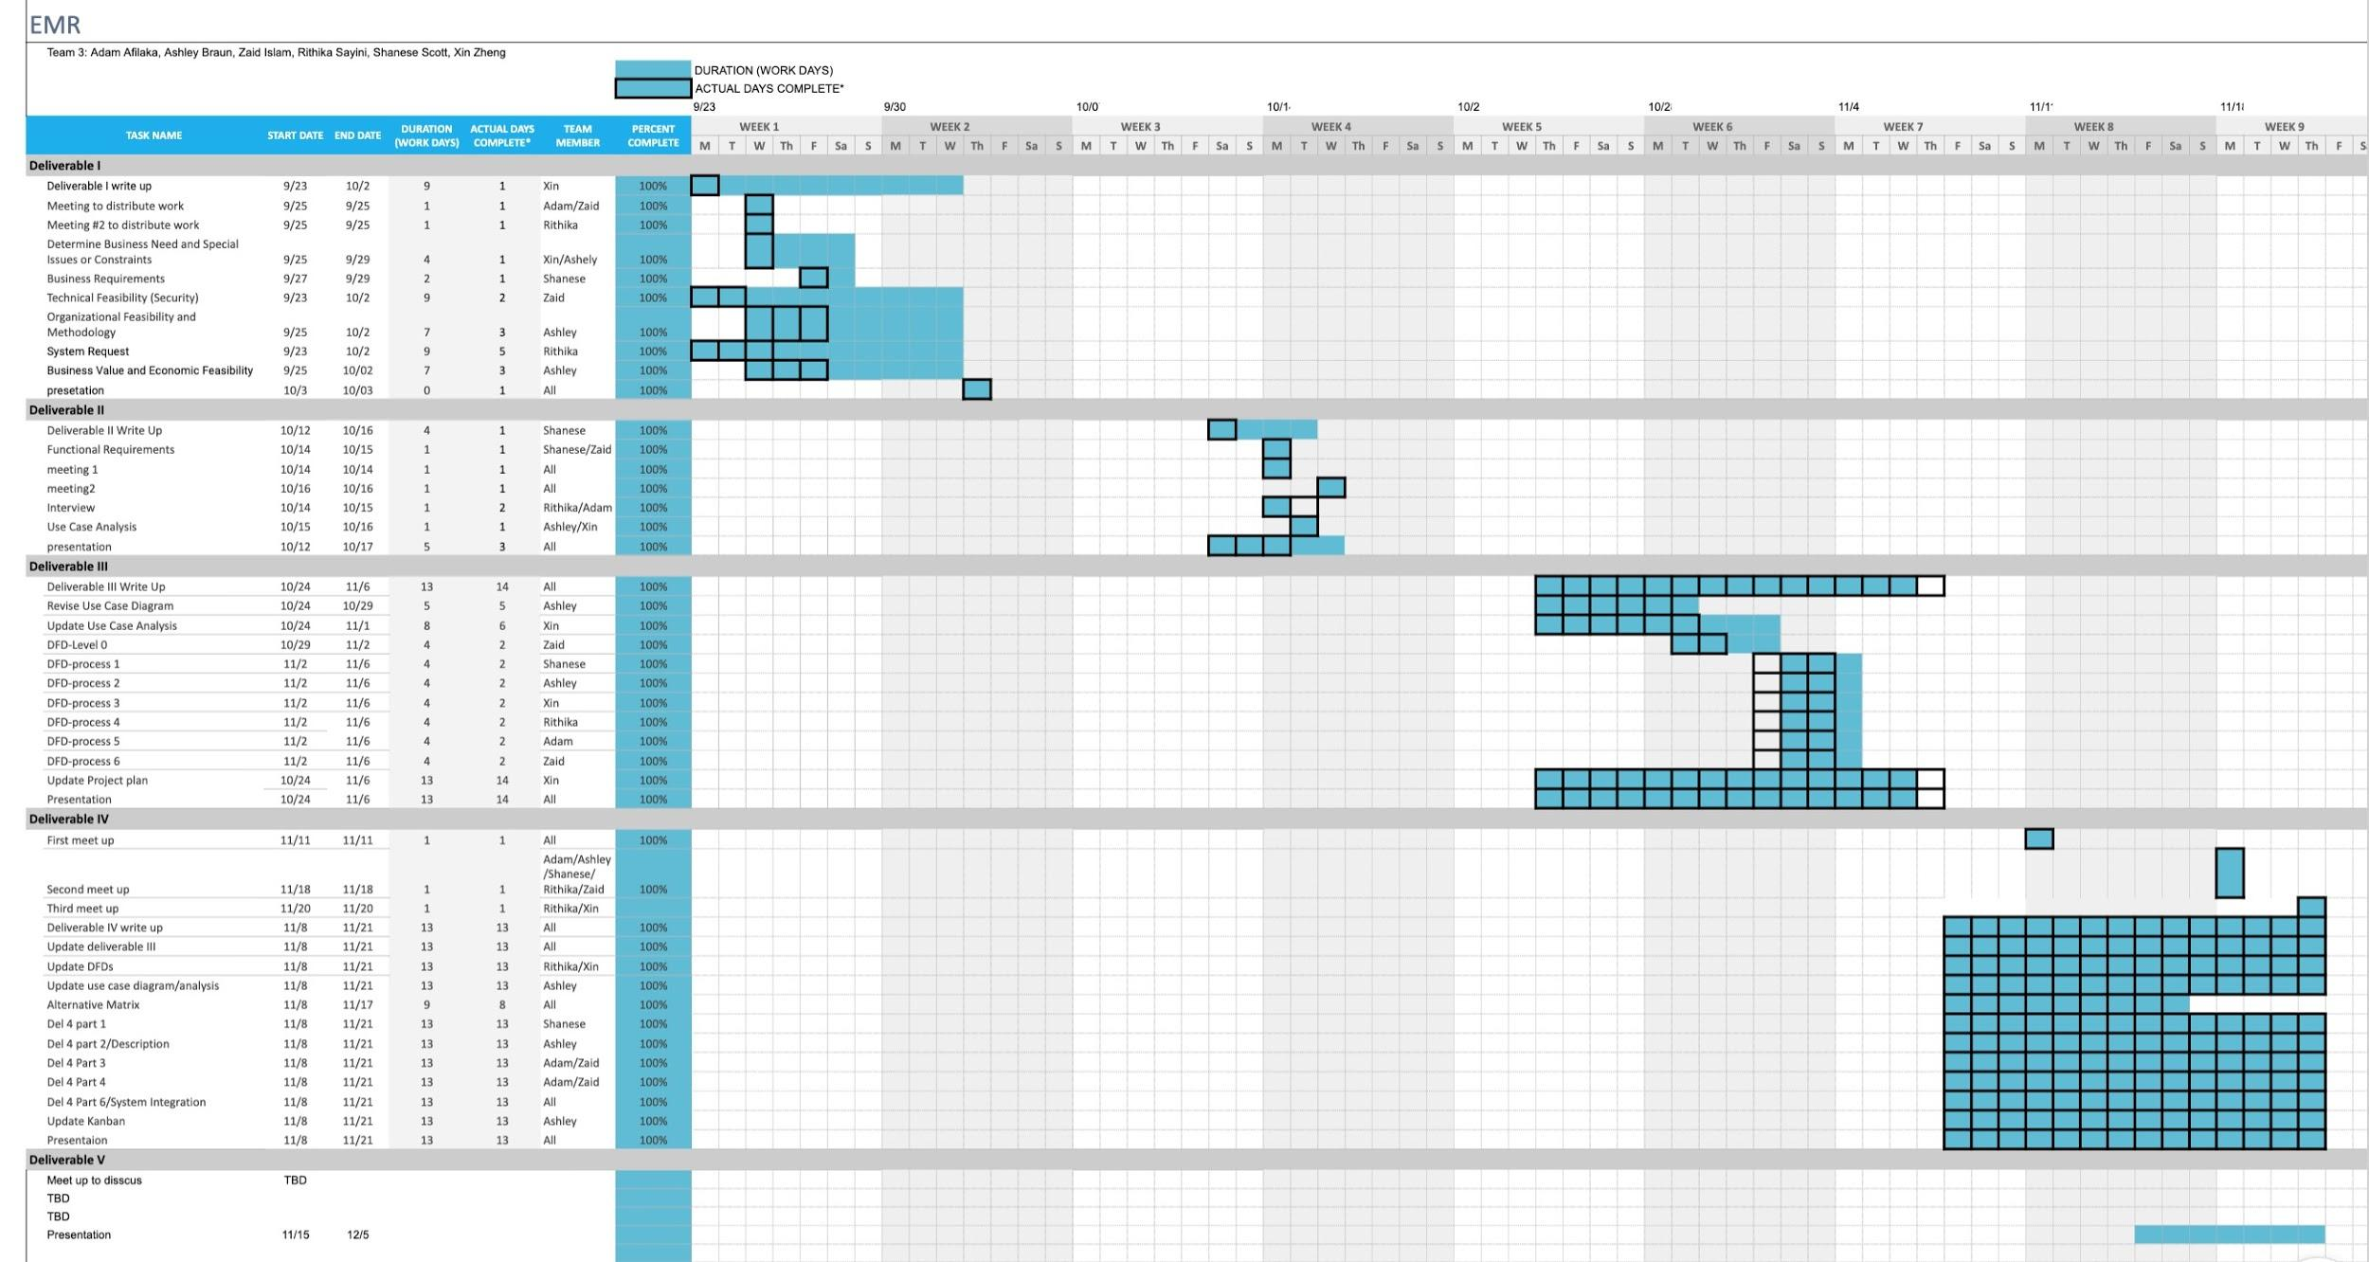

**Kanban Board:**

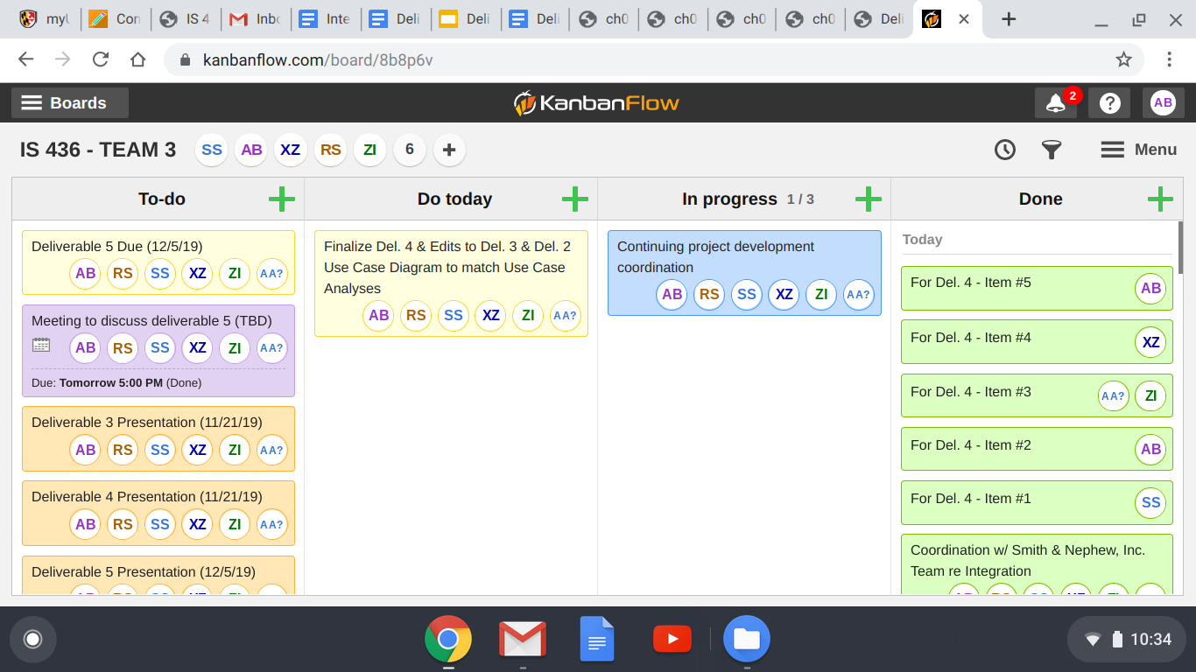

**Appendix A:**

**Updated Use Case Diagram (Analyses following diagram):**

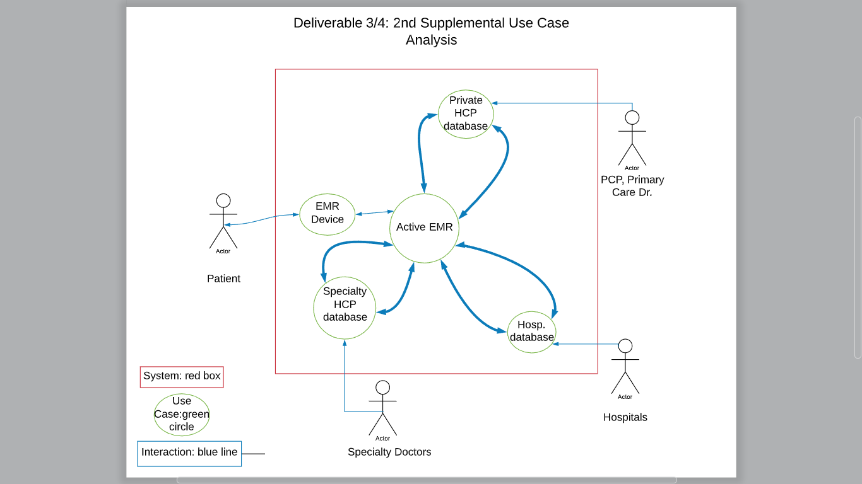

**UC -1**: EMR Device

**UC -2**: Hosp. Database (ER Drs.)/Active EMR/EMR Device

**UC -3**: Specialty Dr./Active EMR/EMR Device

**UC -4**: Private HCP/Active EMR/EMR Device

**UC -5**: Hosp. Database/Active EMR

**UC-1**

|  |  |
| --- | --- |
| **Use Case Field** | Description |
| **Use Case Name:** | Record Patient’s Current Vital Sign |
| **Use Case ID:** | UC-1 |
| **Created By:** | Xin Zheng |
| **Created Date:** | Oct 13, 2019 |
| **Last Update By:** | Xin Zheng |
| **Last Update Date:** | Oct 16, 2019 |
| **Actor:** | Patient |
| **Trigger:** | External: The patient allows the device to collect the data of their vital signs. |
| **Description:** | The patient’s vital signs are constantly being collected by this device, and when anything abnormal happens, it will alter the patient’s data. For example, when there is an abnormal heartbeat is record, it will send warning to patient for potential heart attack . |
| **Precondition:** | 1. Patient has to wear the device. 2. Patient gives the device and database permission to collect and store vital data. 3. The database is up-to-data and on-line. 4. Patient’s medical history is stored in the database. |
| **Post Condition:** | 1. Patient’s vital sign data is stored. 2. The sent warning is also recorded. 3. The collected data will be sent to the doctor to help treat the patient. |
| **Priority:** | High |
| **Frequency of Usage:** | Daily |
| **Normal Course of Event:** | 1.0 Recording patient’s vital sign   1. The patient’s medical history is uploaded to the system. 2. The patient’s vital signs will be recorded in to a pattern.   2.0 Predict the potential adverse event   1. The device will compare collected data to previous pattern of patient’s vital signs.    1. If the abnormality is recorded, it will send out the alert to the patient.    2. The alert specifies the potential illness by referencing the patient’s medical history.   2. The alert will be stored in the alert history.   1. The patient’s doctor will also receive the notification of abnormality. |
| **Alternative Course:** | 1. The doctor’s office will perform manual data entry of vital signs after the patient’s visit. 2. The data manager will reconcile the entered data. |
| **Exception:** | E1. The data collected by the device is inconsistent.   1. The system notified the patient and data manager to valid the highlighted data. 2. It will record into the query list.    1. If both patient and data manager approval for the highlighted data, it will stored without any change.    2. If they found the inconsistency of highlighted data, it will be deleted. 3. The corresponding query will be marked as solved. 4. The patient will be notified the inconsistent data was deleted. |
| **Special requirement:** | The usage of data must follow by the related privacy regulation and other laws. |
| **Assumption:** | The patient is willing to wear and use the devices. Also, the patient gives permission for device to collect his personal health data. |
| **Notes and Issues:** | Additional details and changes will be added to a revised version of UC-1 and name as UC-1.1 if the change is approved. . |

**UC-2**

|  |  |
| --- | --- |
| **Use Case Field** | **Description** |
| **Use Case Name:** | Request medical records and vital signs data |
| **Use Case ID:** | UC-2 |
| **Created By:** | Xin Zheng |
| **Created Date:** | Oct 13, 2019 |
| **Last Update By:** | Xin Zheng |
| **Last Update Date:** | Oct 16, 2019 |
| **Actor:** | An ER doctor (Speciality Doctor) |
| **Trigger:** | The request of medical records and vital signs by the doctor |
| **Description:** | If the patient is having an adverse health event and in a loss conscious state, the data of medical history and vital signs can be exported into ER’s system by the request of doctor. It will help the doctor to diagnose the patient more accurately. |
| **Precondition:** | 1. The patient allows the device to collect personal medical data. 2. The patient wears the device when an emergency happens. 3. The data of patient’s medical history and vital signs is stored in the database. 4. The credential of ER doctors and other staff is stored in the system. 5. The hospital has access to the system. 6. The device is compatible to hospital’s system. |
| **Post Condition:** | 1. The request made by doctor will be stored in the system 2. The patient history will be stored into database as new medical record. |
| **Priority:** | High |
| **Frequency of Usage:** | As it needed. |
| **Normal Course of Event:** | 1.0 request medical record and vital sign data   1. The ER doctor request the needed medical record and vital sign data from the device. 2. The device will verify the credential of the user.    1. If the credential is confirmed, the system will general list of needed medical record and vital signs.    2. If the confirmation is failed, the system will deny the data export. |
| **Alternative Course:** | 1. The patient can give the ER doctor permission if they are not in the pre-existing credential list. 2. Or the hospital can use a universal reading device to read the data in the wearable device. |
| **Exception:** | E1. The patient not allow the ER doctor and staffs to access his data.   1. The ER doctor request the needed medical record and vital sign data from the device. 2. The request will be denied, and the message will be sent to the doctor. |
| **Special requirement:** | Any transfer of the medical data should made by professionals and follow the privacy regulation and laws. |
| **Assumption:** | The patient is wearing the device when emergency happens and also when the patient is in the emergency room. The hospital is allow the device sending data to their system. |
| **Notes and Issues:** | Additional details and changes will be added to a revised version of UC-2, and name as UC-2.1 if the change is approved. |

**UC-3**

|  |  |
| --- | --- |
| **Use Case Field** | **Description** |
| **Use Case Name:** | Oxytocin Hormone Changes in Patient |
| **Use Case ID:** | UC-3 |
| **Created By:** | Xin Zheng |
| **Created Date:** | Oct 13, 2019 |
| **Last Update By:** | Xin Zheng |
| **Last Update Date:** | Oct 16, 2019 |
| **Actor:** | Patient |
| **Description:** | If the patient is having spikes in oxytocin hormone levels during certain processes such as childbirth or lactation, the device should be able to record this change and alert the user. This will also alert the user if they are about to undergo early childbirth. |
| **Precondition:** | 1. The user has inputted the delivery due date for their pregnancy. 2. The user has given the device access to previous and present medical records regarding the pregnancy. 3. The user has inputted the credentials for the hospital and doctors. 4. The user is wearing the device during the time of hormone changes. |
| **Post Condition:** | 1. Oxytocin hormone trend is recorded and displayed 2. User is alerted that they will undergo contractions soon 3. The device alerts the user’s doctor about the upcoming delivery. |
| **Priority:** | High |
| **Frequency of Usage:** | As it needed. |
| **Normal Course of Event:** | 1.0 Device detects spike in oxytocin hormone levels   1. Device compares current oxytocin hormone levels to previous levels. 2. Determines whether there is a drastic change. 3. Alerts the patient of this change and alerts. |
| **Alternative Course:** | 1. If the patient has a sudden spike in oxytocin hormone levels, but the device does not record further increases.    1. This means that the patient is undergoing false contractions    2. Device should alert the user that the spikes were not followed up with consistent increases in oxytocin levels, therefore, the contractions are false. |
| **Exception:** | E1. The patient not allow the ER doctor and staffs to access his data because the user has decided to undergo childbirth outside of hospitals. |
| **Special requirement:** | Any transfer of the medical data should made by professionals and follow the privacy regulation and laws. |
| **Assumption:** | The patient is wearing the device when spike in oxytocin hormone levels occurs. |
| **Notes and Issues:** | Additional details and changes will be added to a revised version of UC-3, and name as UC-3.1 if the change is approved. |

**UC-4**

|  |  |
| --- | --- |
| **Use Case Field** | **Description** |
| **Use Case Name:** | Upload Medical History to database |
| **Use Case ID:** | UC-4 |
| **Created By:** | Xin Zheng |
| **Created Date:** | Oct 26, 2019 |
| **Last Update By:** | Xin Zheng |
| **Last Update Date:** | Nov 6, 2019 |
| **Actor:** | Primary Care Doctor |
| **Trigger:** | External. Patient request Primary Care to upload data to the device.. |
| **Description:** | If the patient is given permission of the device to collect their personal medical data, Primary Care doctor or Office staff will upload patient information that is stored in patient portal to the devices, then the information will be automatically recorded in the database. |
| **Precondition:** | 1. Patient allow the device to collect his personal medical data. 2. Primary Care Doctor willing to share and transfer data to the device and the database |
| **Post Condition:** | 1. The medical records will be uploaded to the database and stored in the devices. 2. Speciality and hospital can extract data from the device in an emergency situation. 3. The devices use medical records to find the pattern and based on the pattern, alert patient when an abnormality is detected. |
| **Priority:** | High |
| **Frequency of Usage:** | As patient requested. |
| **Normal Course of Event:** | 1.0 Primary care upload medical history to the device.   1. Primary care verifies their credentials and login to patient portal. 2. Primary care push the medical record from the patient portal to device. 3. The device stores the uploaded data. 4. Send all data to the database. |
| **Alternative Course:** | 1. If the Primary Care Office record medical records in papers. 2. Patient can request a login account for Doctor's office staff to enter medical history manually. 3. After the data is entered, database admins will reconcile the data to make sure there is not errors.    1. Then, the medical history will send to patient’s device. |
| **Exception:** | E1. Primary Care not willing to transfer medical history to database.  E2. The system or software that used by primary care is in compatible to the devices. |
| **Special requirement:** | Any transfer of the medical data should made by professionals and follow the privacy regulation and laws. |
| **Assumption:** | The patient notify the Primary Care doctor to transfer data with proper request form. |
| **Notes and Issues:** | Additional details and changes will be added to a revised version of UC-3, and name as UC-3.1 if the change is approved. |

**UC-5**

|  |  |
| --- | --- |
| **Use Case Field** | **Description** |
| **Use Case Name:** | Transfer Medical History to database |
| **Use Case ID:** | UC-5 |
| **Created By:** | Xin Zheng |
| **Created Date:** | Oct 26, 2019 |
| **Last Update By:** | Xin Zheng |
| **Last Update Date:** | Nov 6, 2019 |
| **Actor:** | Hospital |
| **Trigger:** | External. Patient request the hospital to share their medical record to the device. |
| **Description:** | If the patient is given permission of the device to collect their personal medical data, hospitals will transfer patient information from the hospital system to their devices, then the information will be automatically recorded in the database. |
| **Precondition:** | 1. Patient allow the device to collect his personal medical data. 2. Hospital willing to share and transfer data to the device and the database. 3. Patient’s medical record is stored in their system. |
| **Post Condition:** | 1. The medical records will be uploaded to the database and stored in the devices. 2. Speciality and other PHP can extract data from the device in an emergency situation. 3. The devices use medical records to find the pattern and based on the pattern, alert patient when an abnormality is detected. |
| **Priority:** | High |
| **Frequency of Usage:** | As patient requested. |
| **Normal Course of Event:** | 1.0 Hospital Transfer medical history to the device.   1. Hospital verifies their credentials and login to patient portal. 2. Hospital transfer the medical record from their system to device. 3. The device stores the transferred data. 4. Send all data to the database. |
| **Alternative Course:** | 1. If hospital system is not compatible to the devices.    1. Patient can request a login account for hospital staff to enter medical history manually.    2. After the data is entered, database admins will reconcile the data to make sure there is not errors.    3. Then, the medical history will send to patient’s device. |
| **Exception:** | E1. The hospital is shorted of staff to transfer medical history to database. |
| **Special requirement:** | Any transfer of the medical data should made by professionals and follow the privacy regulation and laws. |
| **Assumption:** | The patient notify the hospital to transfer data with proper request form. |
| **Notes and Issues:** | Additional details and changes will be added to a revised version of UC-3, and name as UC-3.1 if the change is approved. |